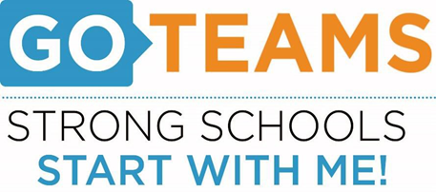

**MEETING NOTICE**

|  |  |  |  |
| --- | --- | --- | --- |
| **School** | **Date** | **Time** | **Location** |
| John Wesley Dobbs | February 22, 2024 | 4:00pm – 6:00pm | Via Zoom:  [**https://atlantapublicschools-us.zoom.us/j/86844117045?pwd=bWxoZ0FQNktIVndtWXY2Mm4yVEtTdz09**](https://atlantapublicschools-us.zoom.us/j/86844117045?pwd=bWxoZ0FQNktIVndtWXY2Mm4yVEtTdz09)    **Meeting ID: 868 4411 7045**  **Passcode: GoTeam**  **Youtube: Dobbs Elementary**  **@dobbselementaryschool8427** |

**Notice Prepared By:** Sonja Yarbrough **Date Posted: 2/22/24 .**

**Meeting Agenda**

(*agenda may be amended*)

*This meeting will allow for Public Comment*

1. **Action Items** 
   1. **Approval of Agenda**
   2. **Approval of Previous Minutes**
2. **Discussion Items** 
   1. **Budget Development Presentation**
   2. **Present Spending Options**
3. **Information Items** 
   1. **Principal’s Report**
      1. **Writing Data & Instructional Updates**
      2. **Ga. Surveys – Administered Students, Staff, & Parents**
      3. **Ga. Literacy Bill – Teacher Requirements**
4. **Announcements**
   1. **Black History Program – February 29th**
   2. **Town Hall Meeting – March 1st**
   3. **Dobbs Food Pantry – March 13th @ 3:00pm – 4:40pm**
   4. **Ladies Of Literacy Event – March 28th**
   5. **Autism Gala – April 19th**
5. **Public Comment**
6. **Adjournment**